# Lab 3.

## Fill in the blank Questions

1. What is the final value (in C++) of the following expression? ( 5 - 16 / 2 * 3 + (3 + 2 / 2) - 5). **-4.33**
2. How would the following expression be written  in C++?  2x + 34 . **2 * x + pow (2,4)**
3. Implicit conversion is also known as data type **floating point**
4. Explicit type conversion is also known as data type **cast/type casting/ type conversion.**
5. LIst the preprocessor directive that must be included for cin and cout to be used in a C++ program. **#include <iostream>**
6. Blank spaces or unseen control characters in a data file are referred to as **Whitespaces**
7. The << in a cout statement is called the **insertion/left-shift** operator.
8. The #include <**iomanip**> is needed for formatted output.
9. The ‘\n’ is a special character that **creates a new line**

## 3.1 Working with the cin Statement

The program asked to input codes that would work almost in a supermarket type of way. The code that was used first was this.

**// This program will read in the quantity of a particular item and its price.**

**// It will the nprint out the total price.**

**// The input will come from the keyboard and the output will go to the screen.**

**// Jamal Caesar**

**#include <iostream>**

**#include <iomanip>**

**using namespace std;**

**int main()**

**{**

**int quantity;               // contains the amount of items purchased**

**float itemPrice;            // contains the price of each item**

**float totalBill;            // Contains the total bill.**

**cout << setprecision(2) << fixed << showpoint; // formatted output**

**cout << "Please input the number of items bought " << endl;**

**cin >> quantity;**

**cout << "Now enter the price of the items bought " << endl;**

**cin >> itemPrice;**

**totalBill = itemPrice * quantity;**

**cout << "Total bill of the items are " << totalBill << endl;**

**return 0;**

**}**

It then asked to input a certain quantity and price which were 22 and 10.98 respectively.

This is the image of the program’s results.

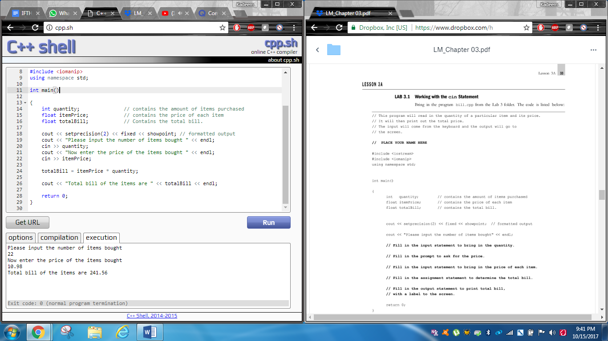

Exercise 2.

This is when the program had to change it’s cout << setprecision (2) << fixed << showpoint; to cout << setprecision(2) << showpoint;

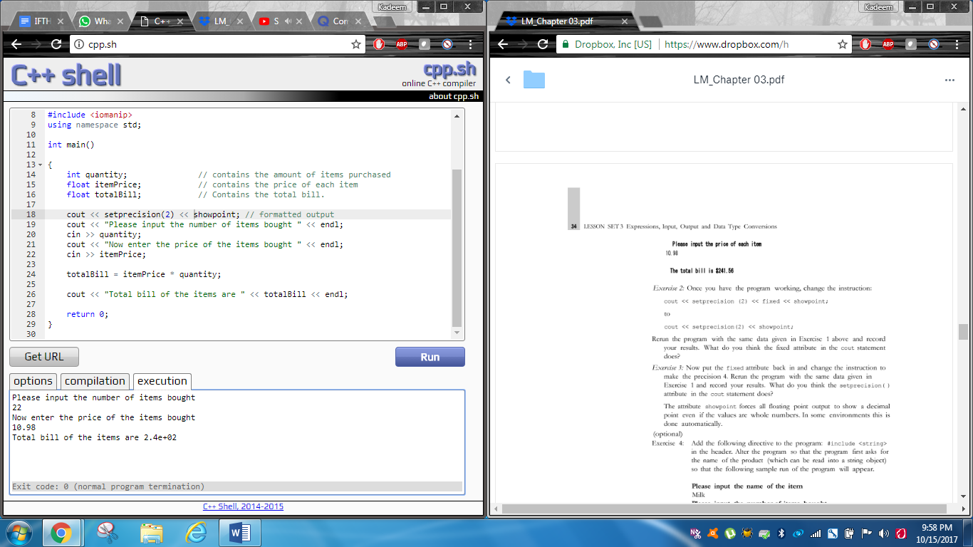

Exercise 3 and 4

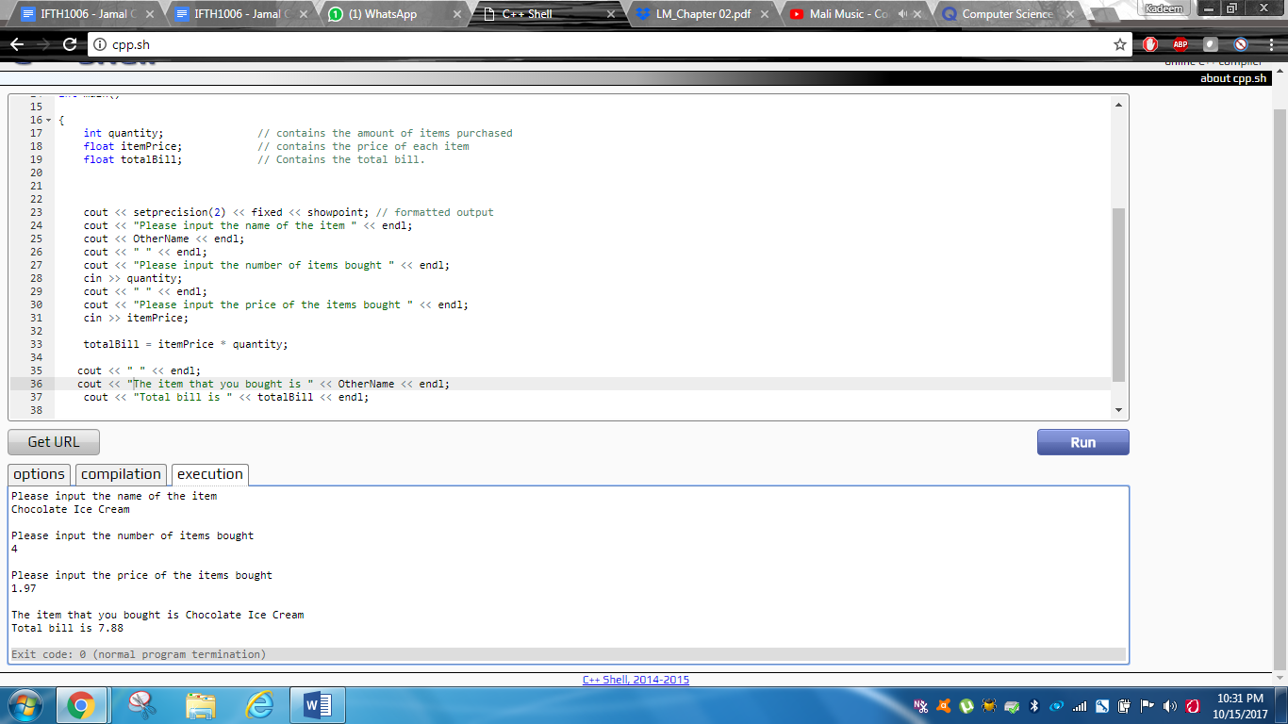

The code for it to occur.

// This program will read in the quantity of a particular item and its price.

// It will then print out the total price.

// The input will come from the keyboard and the output will go to the screen.

// Jamal Caesar

#include <iostream>

#include <iomanip>

#include <string>

using namespace std;

const string Nameofitem = "Milk";

const string OtherName = "Chocolate Ice Cream";

int main()

{

   int quantity;               // contains the amount of items purchased

   float itemPrice;            // contains the price of each item

   float totalBill;            // Contains the total bill.

   cout << setprecision(2) << fixed << showpoint; // formatted output

   cout << "Please input the name of the item " << endl;

   cout << OtherName << endl;

   cout << " " << endl;

   cout << "Please input the number of items bought " << endl;

   cin >> quantity;

   cout << " " << endl;

   cout << "Please input the price of the items bought " << endl;

   cin >> itemPrice;

   totalBill = itemPrice * quantity;

  cout << " " << endl;

  cout << "The item that you bought is " << OtherName << endl;

   cout << "Total bill is " << totalBill << endl;

   return 0;

}

## Lab 3.2

// This program will bring in two prices and two quantities of items

// from the keyboard and print those numbers in a formatted chart.

// Jamal Caesar

#include <iostream>

#include <iomanip>

using namespace std;

int main()

{

   float price1, price2;

   int quantity1, quantity2;

   cout << setprecision(2) << fixed << showpoint;

   cout << "Please input the price and quantity of the first item" << endl;

   cin >> price1 >> quantity1;

   cout << "Please input the price and quantity of the second item" << endl;

   cin >> price2 >> quantity2;

   cout << setw(15) << "PRICE" << setw(12) << "   QUANTITY\n\n";

   cout << setw(15)<< price1 << setw (5) << quantity1 << endl;

   cout << setw(15)<< price2 << setw(5) << quantity2 << endl;

   return 0;

}

Image of the program.

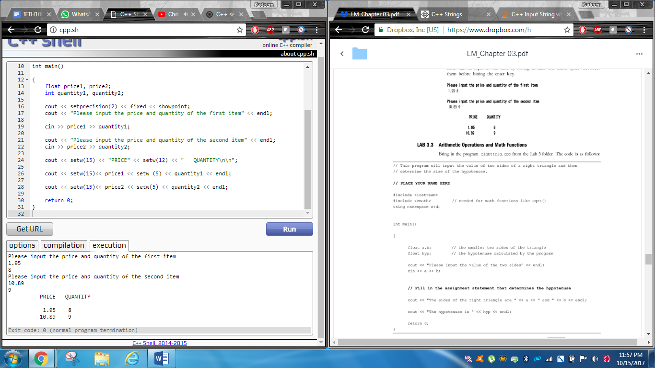

## Lab 3.3

The image of the code.

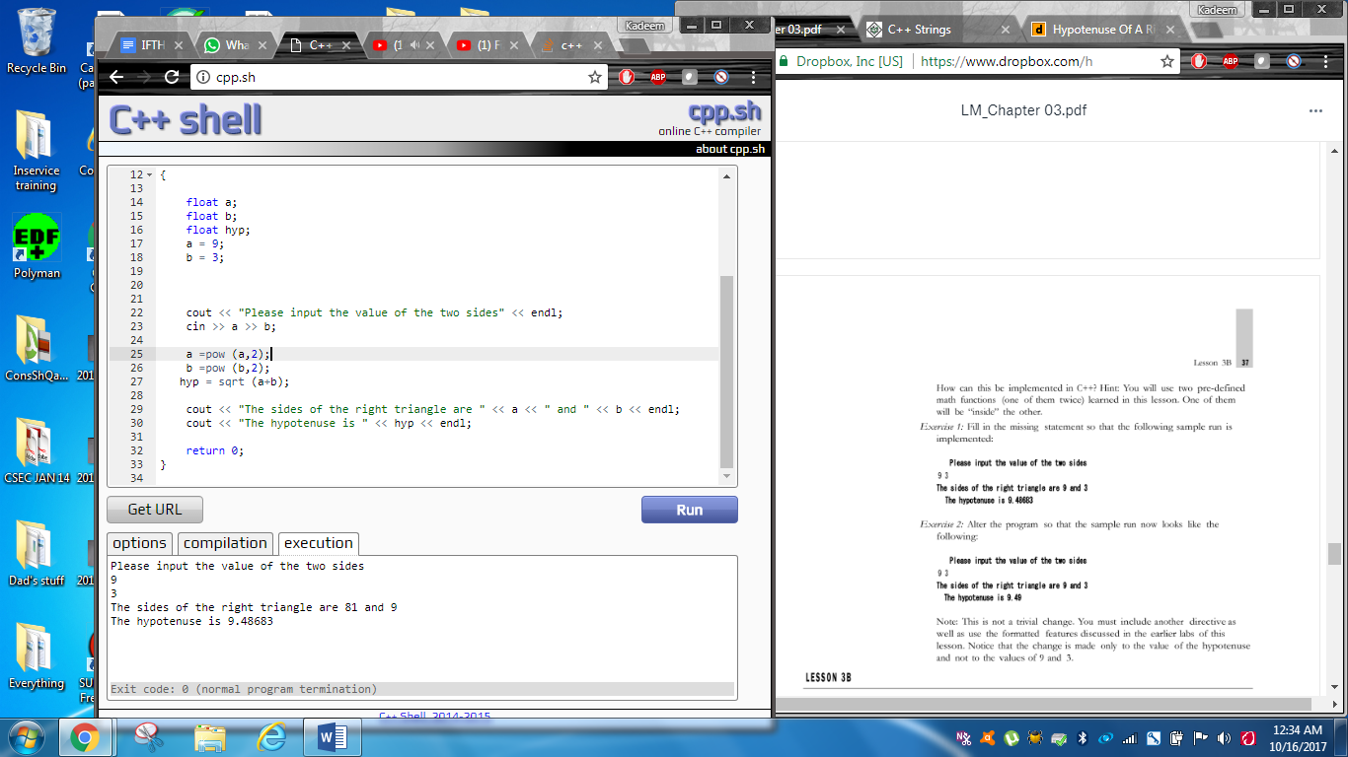

The program’s algorithm.

**// This program will input the value of two sides of a right triangle and then**

**// determine the size of the hypotenuse.**

**// Jamal Caesar**

**#include <iostream>**

**#include <cmath>**

**using namespace std;**

**int main()**

**{**

**float a;**

**float b;**

**float hyp;**

**a = 9;**

**b = 3;**

**cout << "Please input the value of the two sides" << endl;**

**cin >> a >> b;**

**a =pow (a,2);**

**b =pow (b,2);**

**hyp = sqrt (a+b);**

**cout << "The sides of the right triangle are " << a << " and " << b << endl;**

**cout << "The hypotenuse is " << hyp << endl;**

**return 0;**

**}**

Exercise 2

The algorithm of the code

**// This program will input the value of two sides of a right triangle and then**

**// determine the size of the hypotenuse.**

**// Jamal Caesar**

**#include <iostream>**

**#include <cmath>**

**#include <iomanip>**

**using namespace std;**

**int main()**

**{**

**float a;**

**float b;**

**float hyp;**

**a = 9;**

**b = 3;**

**cout << setprecision(2) << fixed << showpoint << endl;**

**cout << "Please input the value of the two sides" << endl;**

**cin >> a >> b;**

**a =pow (a,2);**

**b =pow (b,2);**

**hyp = sqrt (a+b);**

**cout << "The sides of the right triangle are " << a << " and " << b << endl;**

**cout << "The hypotenuse is " << hyp << endl;**

**return 0;**

**}**

The image of the code.

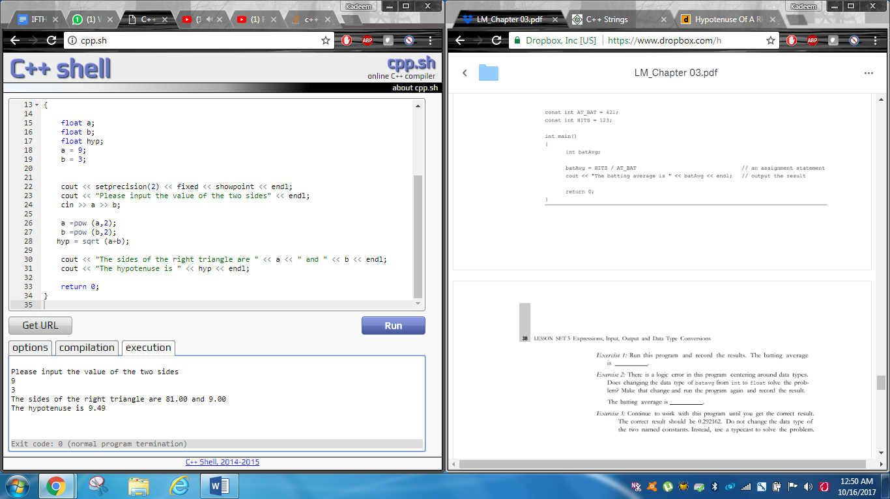

## Lab 3.4

Exercise 1 The batting average is **0.**

Exercise 2:

Image of the code after changing the data type of batavg from int to float

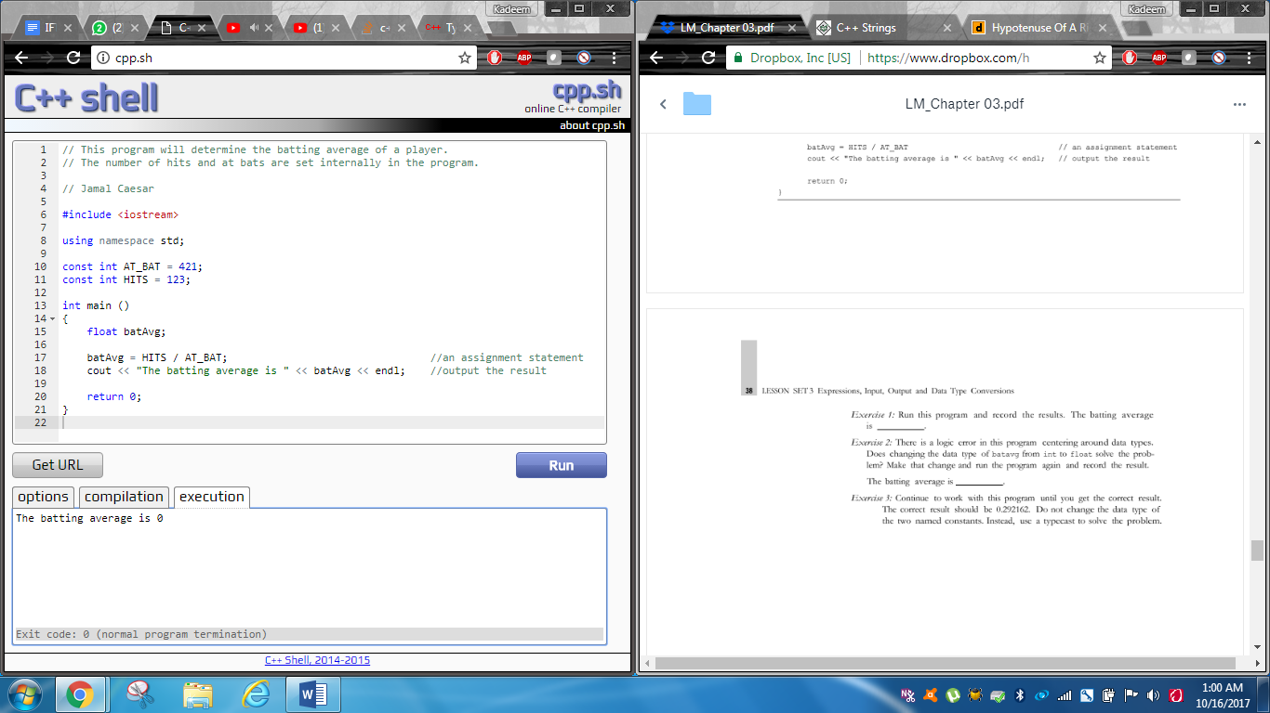

Exercise 3

Algorithm and image afterwards.

**// This program will determine the batting average of a player.**

**// The number of hits and at bats are set internally in the program.**

**// Jamal Caesar**

**#include <iostream>**

**using namespace std;**

**const int AT_BAT = 421;**

**const int HITS = 123;**

**int main ()**

**{**

**float batAvg;**

**batAvg = static_cast <float> (HITS) / AT_BAT;                                 //an assignment statement**

**cout << "The batting average is " << batAvg << endl;    //output the result**

**return 0;**

**}**

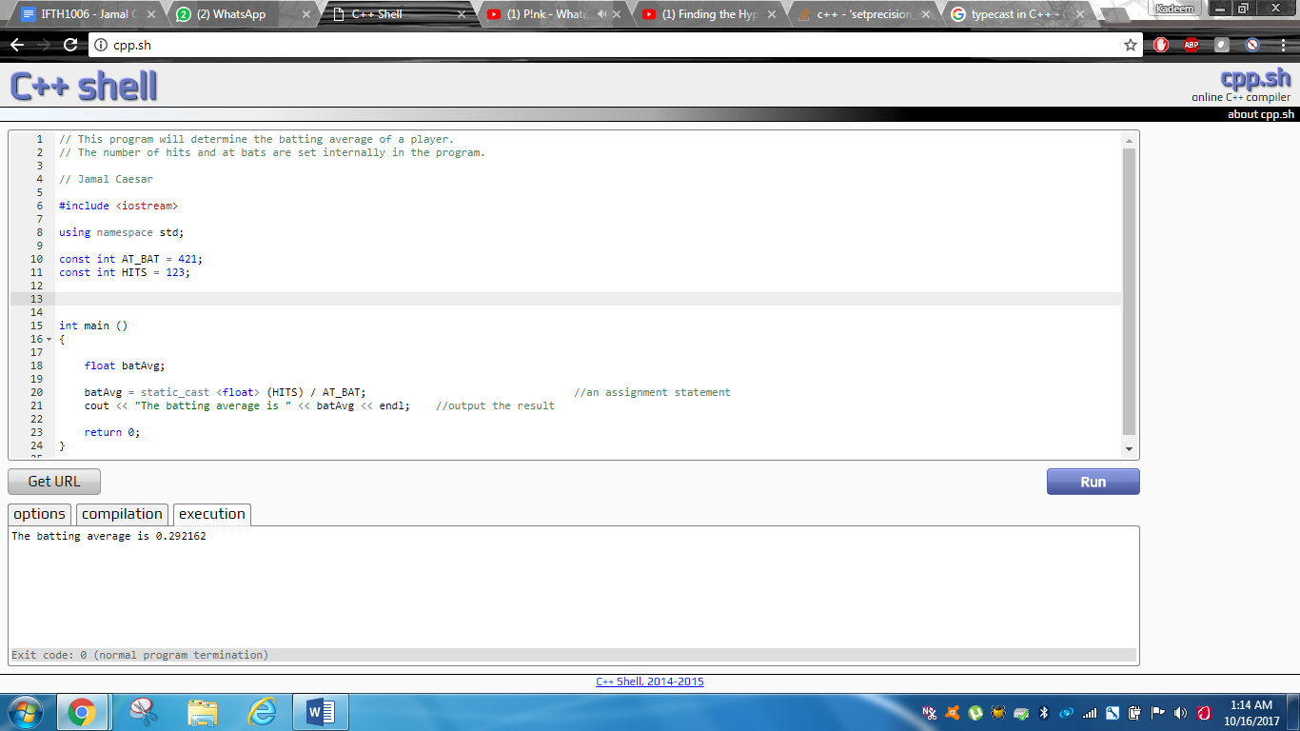

## 3.5

**Algorithm used to do the first coding option**

**//This program shows the input of 3 grades from keyboard to be printed**

**// with the average to 2 decimal places.**

**// Jamal Caesar**

**#include <iostream>**

**#include <iomanip>**

**using namespace std;**

**float Firstgrade;**

**float Secondgrade;**

**float Thirdgrade;**

**float total;**

**float avg = 3;**

**int main()**

**{**

**cout << setprecision(2) << fixed << showpoint;**

**cout << "Please input the first grade" << endl;**

**cin >> Firstgrade;**

**cout << "" << endl;**

**cout << "Please input the second grade" << endl;**

**cin >> Secondgrade;**

**cout << "" << endl;**

**cout << "Please input the third grade" << endl;**

**cin >> Thirdgrade;**

**total = Firstgrade + Secondgrade + Thirdgrade;**

**avg = total/avg;**

**cout << "The average of the three grades is " << avg << endl;**

**return 0;**

**}**

**Image of the program**

